

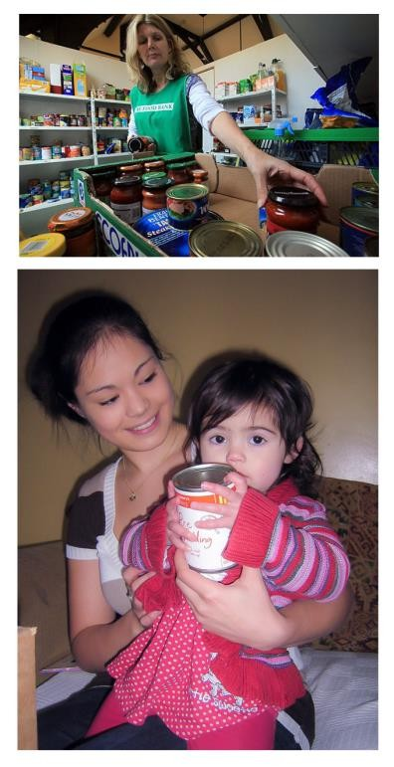

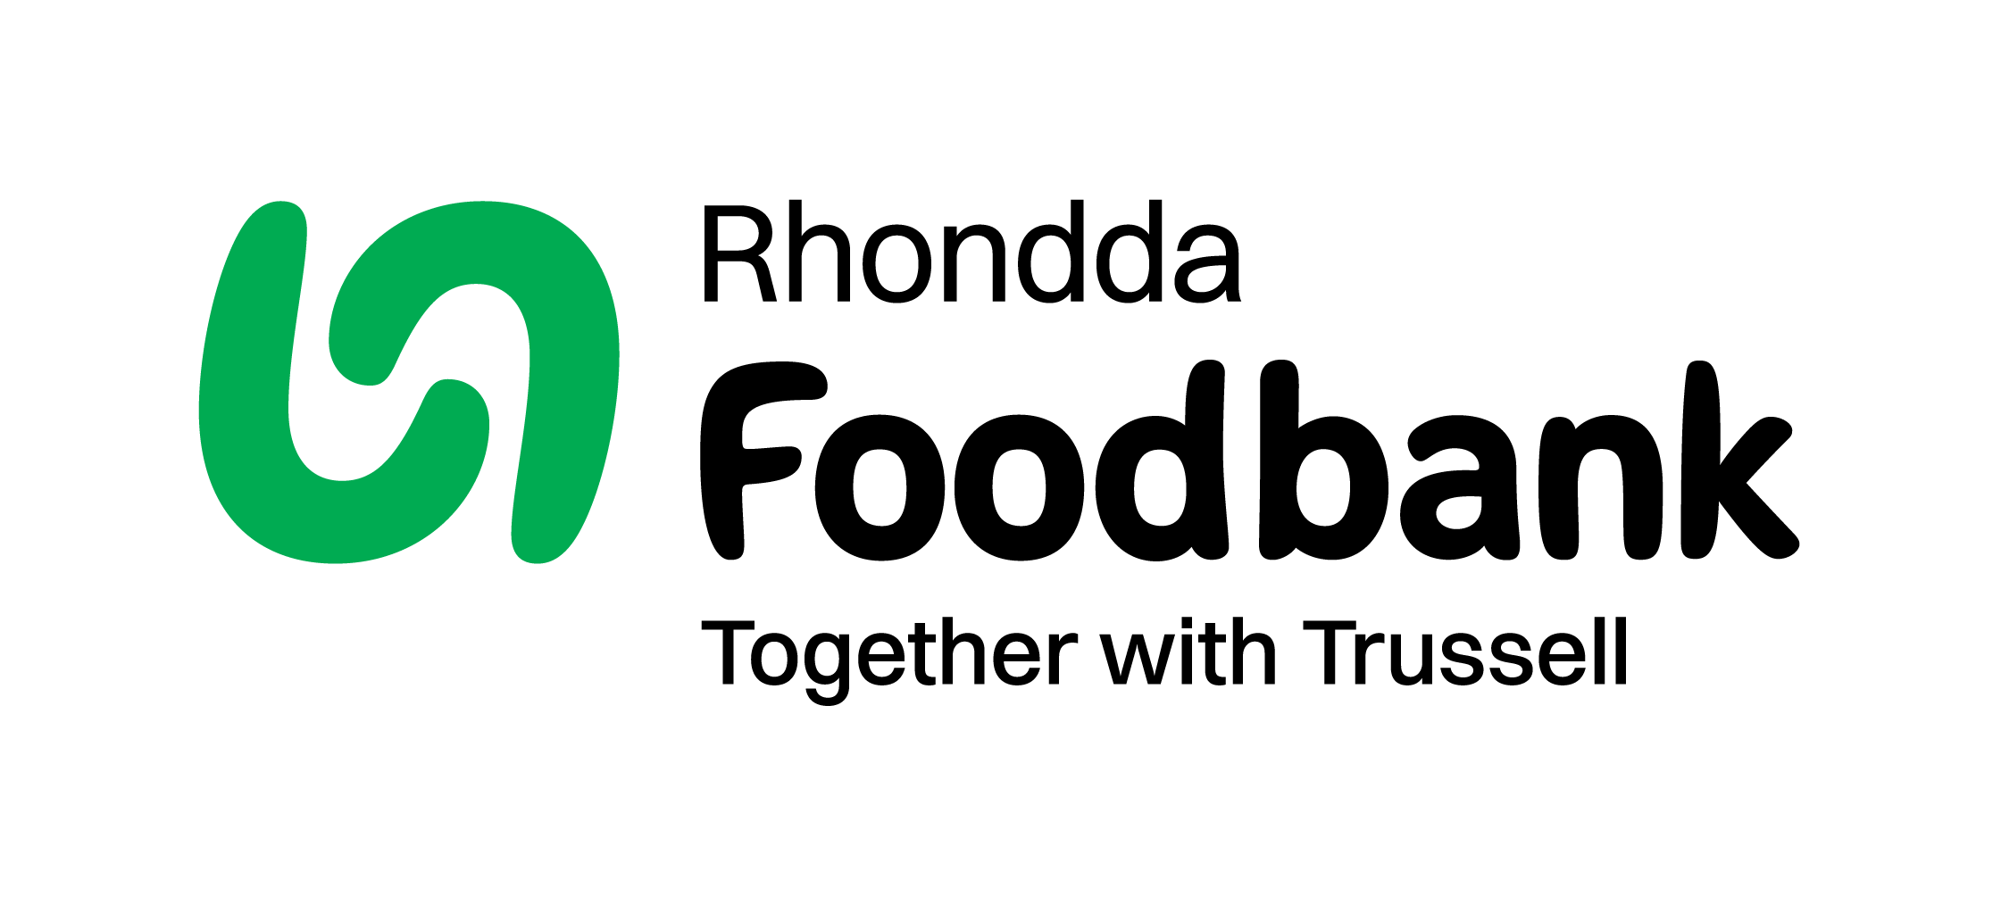
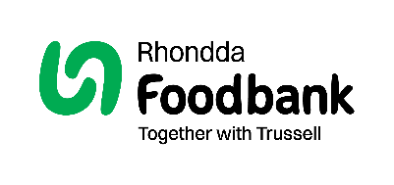

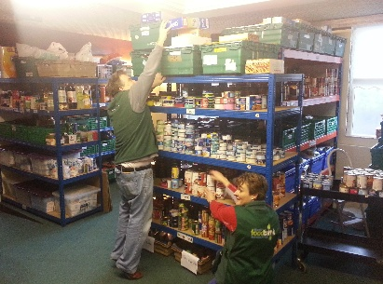
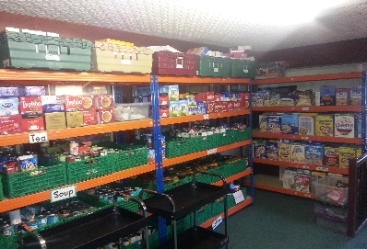
About Rhondda foodbank
Could you partner with Rhondda foodbank and join the 200 Club?
We appreciate all the different ways that people support Rhondda foodbank, from donating food to volunteering, holding fundraising events, and one-off gifts.
Another amazing way of supporting us is to commit to our 200 Club.

Could you be one of 200 people to commit £5 a month or more to support our work?
Your regular giving will provide emergency food and support local people in crisis.
It will also help us to budget effectively and demonstrate to other potential funders that our foodbank is sustainable.
Donate to Rhondda foodbank
Find out about the different ways to donate on our website or simply fill in the form on the next page and we’ll do the rest!
www.rhondda.foodbank.org.uk
If you are a UK tax payer, we can also claim an extra 25p with every £1 you donate at no extra cost to you.
Rhondda foodbank opened in Nov 2009 to give people in crisis hope, practical help, and a brighter future. We value all of our supporters who make a big difference.
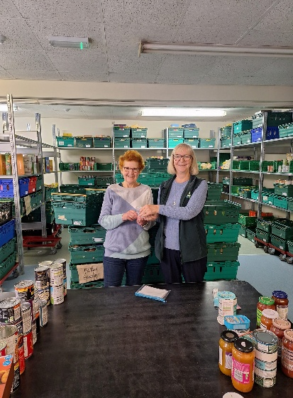
Over 1 in 5 people live below the poverty line in the Rhondda We provide three days’ emergency food and support to local men, women and children in crisis. Our vision is to ensure that no-one in the Rhondda has to go hungry.

Food Donations
All of our food is generously donated by people in the local community (schools, businesses, churches and individuals) and volunteers of all backgrounds help to sort, pack, and distribute food parcels to individuals and families in need. Local people are feeding local people.

Frontline Care Professionals
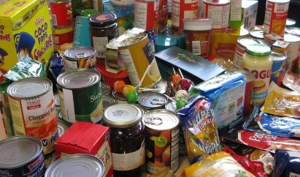
The families and individuals who come to us have been referred by care professionals.
Social workers, health visitors, school liaison officers and others, work with us to help people in crisis so that they do not have to go hungry.
Standing Order Mandate
Rhondda.foodbank.org.uk

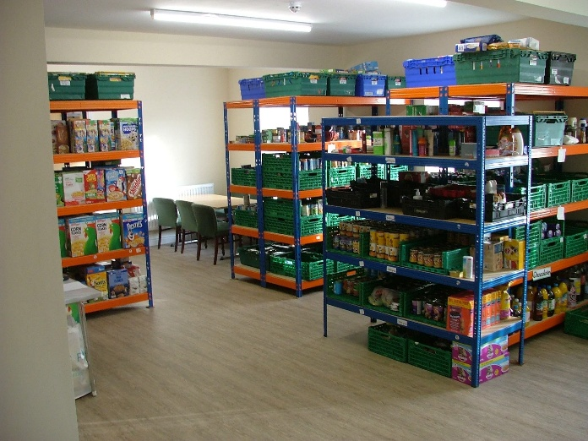
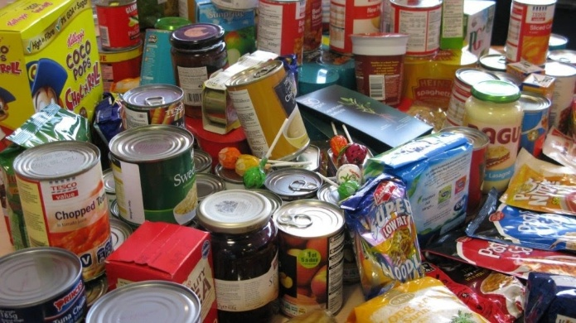

Join the 500 Club and help local people in crisis

Rhondda Foodbank
Ashfield House
230 East Road
Tylorstown
CF43 3DA
Contact
Tel: 07928 451 374 | 01443 548254
Email info@rhondda.foodbank.org.uk Website www.rhondda.foodbank.org.uk

Charity Number: 1136590 Registered in England & Wales/Scotland

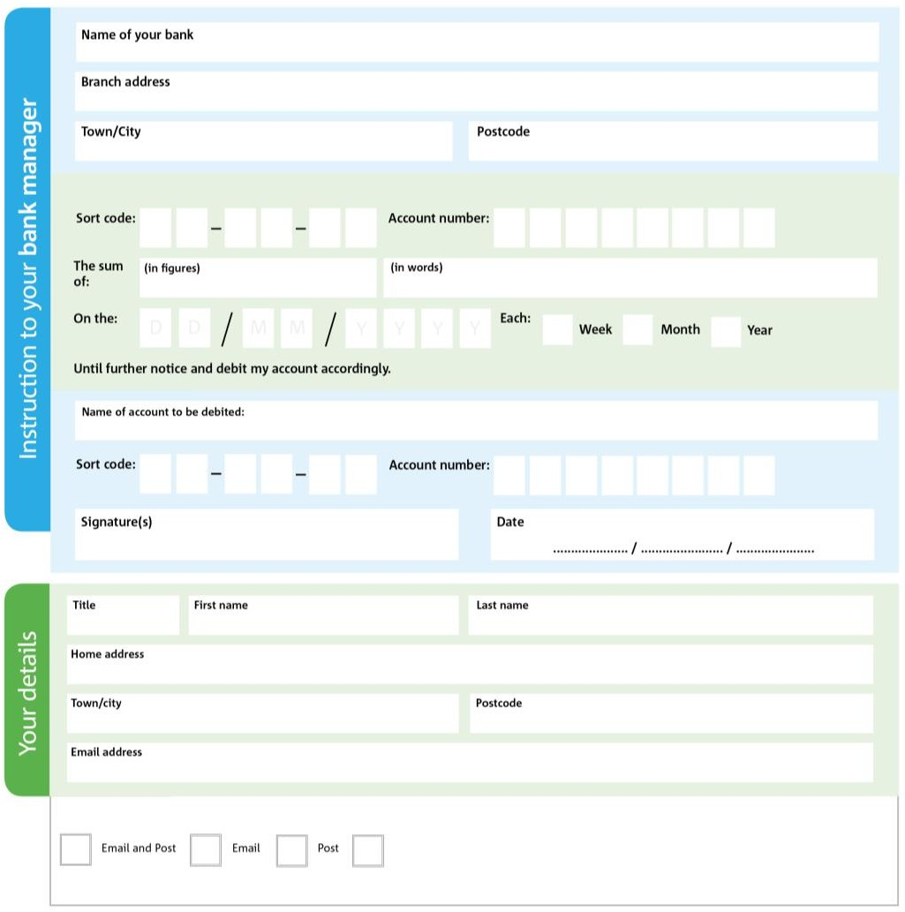
Please pay Rhondda Foodbank

2 0 6 8 7 6
7 3 3 0 3 1 6 0
We would love to keep you up to date with information about the Rhondda Foodbank. Please tick your

I do not wish to receive future communications from Rhondda Foodbank
You can change your preferences any time by contacting us on 07928451374 or emailing us at info@Rhondda.foodbank.org.uk
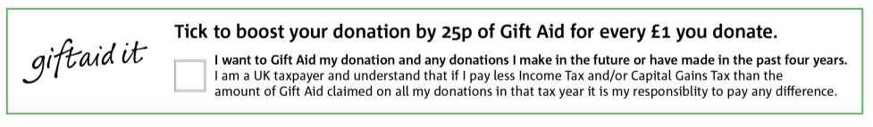

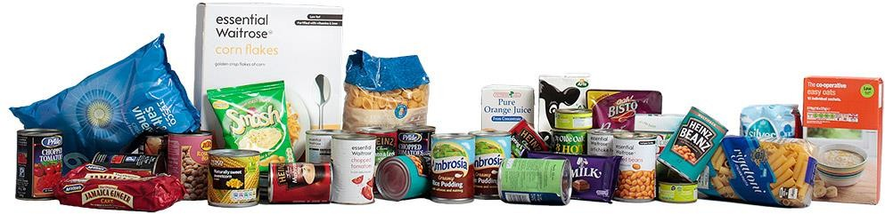
Data protection
Rhondda Foodbank is committed to protecting your privacy and will process your personal data in accordance with current Data Protection legislation. Rhondda Foodbank collects information to keep in touch with you and supply you with information relating to our work. To unsubscribe from our newsletter, send a message to the email address above with the word unsubscribe in the subject line. A full data privacy statement for financial donors is available from the foodbank on request.
Please pass this form onto the foodbank, using the foodbank’s address at the bottom, they will save a copy for their records. They will then send it onto your named bank or building society.

